Brief description of the origin of Vinayaga
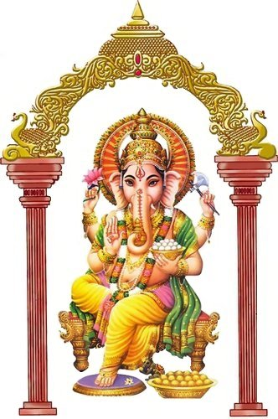
The following story is narrated about Lord Vinayaga’s birth and how he came to have the head of an elephant.
One day, while bathing, Goddess Gauri (the consort of Lord Siva), created Vinayaga as a pure white being out of mud of her body and placed him at the entrance of her house. She told him not to allow anyone to enter while she went inside for a bath. When Lord Siva returned home quite thirsty, he was stopped by Vinayaga at the gate. Siva became angry and cut off Vinayaga’s head thinking that he was an outsider.
When Gauri came to know of this she was sorely grieved. To console her, Siva ordered his servants to cut off and bring him the head of any creature that might be sleeping with its head facing north. The servants went on their mission and found only an elephant in that position. The sacrifice was thus made and the elephant’s head was brought to Siva.
The Lord then joined the elephant’s head onto the body of Vinayaga.

What does VINAYAGA CHATHURTHI mean:
VINAYAGA – means the supreme LORD
CHATHURTHI – means the 4th day after the new moon
There is a Chathurthi every month but the Chathurthi that falls in the Tamil month of Aavani (August – September) is considered auspicious for the worship of Vinayaga which is known as Maha Vinayaga Chathurthi (It is a great day for the worship of the supreme LORD).

Symbolism of Vinayaga

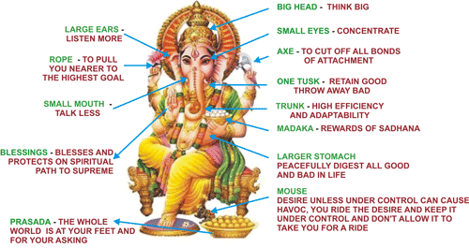

AUM AUM AUM
Aum/Om is Prananvam the vital breath which is the sound/audible symbol of the all pervading consciousness Vinayaga.

Symbolic Meaning:
The elephant’s head if looked at closely forms the symbol of AUM which is the most auspicious and holy symbol for Hindu’s.
The large ears symbolize how easy it is for him to pick up the minutest sound. The large ears also reaffirm the omniscientness (all knowing) of the LORD.
The trunk can pick up large, heavy and the smallest objects. The trunk also represents intellect. The intellect is a power of man which promotes wisdom.
The tusk was broken off by Vinayaga and used to write the Maha Baratham which symbolizes that no sacrifice is too great for a noble cause. The tusk is also symbolic by showing that Vinayaga is unswayed by any challenges.
The large stomach of the LORD signifies the entire universe with all objects and beings of the world.
His two legs – 1 leg folded meaning always deep rooted in meditation. The 1 leg on the ground always dealing with worldly matters.
The four arms – his right backward hand holds an axe signifies the cutting away of desires and attachments. In his right forward hand he holds a lotus flower representing the supreme goal of human evolution
The left backward hand noose (rope) this is used to pull his devotees from worldly attachment and to direct them on to the spiritual path.
The left forward hand he holds a sweet rice ball (modakam) signifies the joys and rewards of spiritual progress.
The vehicle (Vahanam - Rat) the vehicle which is the rat symbolizes man’s desires which continues to worry him. Vinayaga riding on the rat signifies the suppressing of desires and the attainment of spiritual goals.

Few forms of Vinayaga:
Bakthi Ganapathi – God of the devotees
Maha Ganapathi – The great one
Uddanda Ganapathi – The punisher of evil
Bala Ganapathi - The beloved child
Siddhi Ganapathi – God of achievement
Ekadanta Ganapathi – The Lord with one tusk Shakthi Ganapathi – The powerful one
Vigna Ganapathi – The remover of obstacles
Veera Ganapathi – The valiant warrior
Lutchmee Ganapathi – The giver of success

Requirements for the prayer:
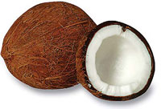
1 Coconut
1 Pkt Borrie(Turmeric powder)
1 Pkt kumgum
1 Pkt Kadam podi
7 betel leaves(5 if only making Pillaiyaar)
7 betel nuts(5 if only making Pillaiyaar)
Flowers for garland and petals
1 Pkt incense sticks
2 Pkts camphor
3 Kind of Fruit
1 Pint milk
Sweetmeats or (prepare something sweet)
¼ Kg White rice
¼ meter yellow or white cloth
Avaal Kadal and sugar candy
Dates

A general description of how one should conduct the Vinayaga:

Preparations for the Prayer:
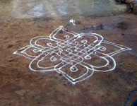
A vegetarian diet should be observed for the entire day (on the day of prayer).
The entire house should be cleansed (day before prayer).
One should wash their lamp and dot it with borrie and kumgum (day before prayer).
One should prepare something sweet in their homes (e.g. sweet rice, soji etc) (morning of prayer)
A korlam should be made at the front entrance of the house using either rice flour or mealie meal (morning of prayer). (When making the korlam ensure that you have enough space to walk around.)
A garland should be made using fresh flowers and mango leaves if available.
The garland must be hung on the door (morning of prayer).
The prayer should be observed between 4.00AM – 6.00AM (morning) or from 6.00PM in the evening.

There are two ways of performing your prayer:

With Vinayaga (made with borrie), Kalasha or BOTH

With Vinayaga

How to make a Vinayaga
Take some borrie (turmeric powder) mix water or rose water to form a thick paste. Mould into a mountain like shape thereafter a kumgum dot should be placed in front and sprinkle kadam podi over Vinayaga. A piece of grass having 1 stem and 3 blades of grass (Arum pul) favorite offering to Vinayagar placing it on top of the head.
If you would like to mould the Vinayaga you can make two ears and a trunk in the center, kumgum may be placed on the trunk and between the ear and the trunk to form eyes. The grass (Arum pul) favorite offering to Vinayagar may be placed on the bottom of the trunk.
If you have a brass, copper or wooden murti it may also be used for the prayer.
*Arum pul is a wild type of grass.

Simple procedure on how to perform the Prayer (Pooja)

Prayer must be done facing east(Ganesha must face east)
Place a betel leave and nut with a flower and a coin on a medium size tray.
Place Vinayaga on top of the betel leave.
Offerings of sugar candy avaal kadal, dates, fruit and milk, sweet meats or prasadam that has been prepared may be place in front of the Vinayaga.
1 coconut in front of Vinayaga.
The door should be opened and camphor must be turned facing east (sunrise).
Thereafter you should place the tray with Vinayaga on the korlam.
Turn camphor for Vinayaga 3 times clockwise then walk around the korlam clockwise 3 times.
Welcome Vinayaga into the house and place it at your prayer place.
The lamp should be placed in front or on the side of the Vinayaga.
Light 5 incense sticks and turn it 3 times clockwise around Vinayaga.
Vinayaga may be invoked by offering flower petals with yellow rice or grass (Arum pul) by chanting the following mantra (mantra’s maybe chanted 18, 27 or 108 times).

OM GUM GANAPATAYEI NAMAHA OR POTRI

Om and salutations to the remover of obstacles for which Gum is the seed
OM – means the place at the brow center here the masculine and feminine currents meet.
GUM – means the seed.
Ganapathi – means the principal or deity.
YEI – means the shakti activating sound.
NAMAHA – means I offer
POTRI - Salutation unto

GANESHA GAYATRI MANTRA:
OM EKADANTAYA VIDMAHAE,
VAKRATUNDAYA DHIMAHI,
TANNO DANTIHI PRACHODADAYAT

May Ganapathi/Ganesha which is brighter that a thousand suns and who is worthy of adoration enlighten me.
Turn coconut clockwise 3 times and break. Place 2 halves on either side of Vinayaga.
Turn the 5 incense sticks.
Turn camphor
Sprinkle water over prasadam.
Kneel down and pray.
A song or a prayer can be sung in praise of Vinayaga.
You should leave the prayer place for at least 5 minutes without any disturbance

Vinayaga Thuthi - Prayer To Vinayaga
GAJAANANAM BHUUTHA GANAATHI SETVITHAM
The one who is the 5 gross elements in nature and is served by the host of Lord Siva’s attendance.
KAPITTHA JAMBU PALA SAARA BHAKSHITAM
And the one who part take of the ripe celestial fruit of wisdom
UMAA SUTHAM SOHGA VINAASA KAARANAM
Who is the son the of UMAA, and who causes the destruction of sorrow
ANAMAAMI VINESHVARA PAATHE PANGAJAM
I prostrate to the lotus feet of the removal of obstacles

Prayer To Vinayaga In English
Beloved Ganesha, Thank you for smoothing my path today,
With harmony and peacefulness reigning supreme.
I appreciate you walking before me, clearing all obstructions that could impede my progress. Help me see the blessings within everything today.
Thank you”.

Vinayaga Song
INBE VINAYAGA
Inbe Vinayaga
Yezil Malar Paadham Pannindh (Inbe)
Anbu-male Solayil Ama-randh-thidum Arese
Aathaa-rum Neeye Aandarul Vaaye (Inbe)
Idhaye Malar Thanil Inith-thidum Kaniye
Yendrum Whula-vum Anbai Ini-ye
Nidhe-mum arul-pugazh Inain-thidal Ven-dum
Nenjil Vanjam Neeng-gidal Vendum (Inbe)
Oh sweet great Lord
I bow at to your beautiful lotus feet.
Oh King who abides in the hearts of devotees.
You are our support who protects us by your grace.
In the flower of our hearts you are the sweet fruit.
Remove all deceit from your hearts.

